Name___________________________________
Period_________________
Points: _____________/100

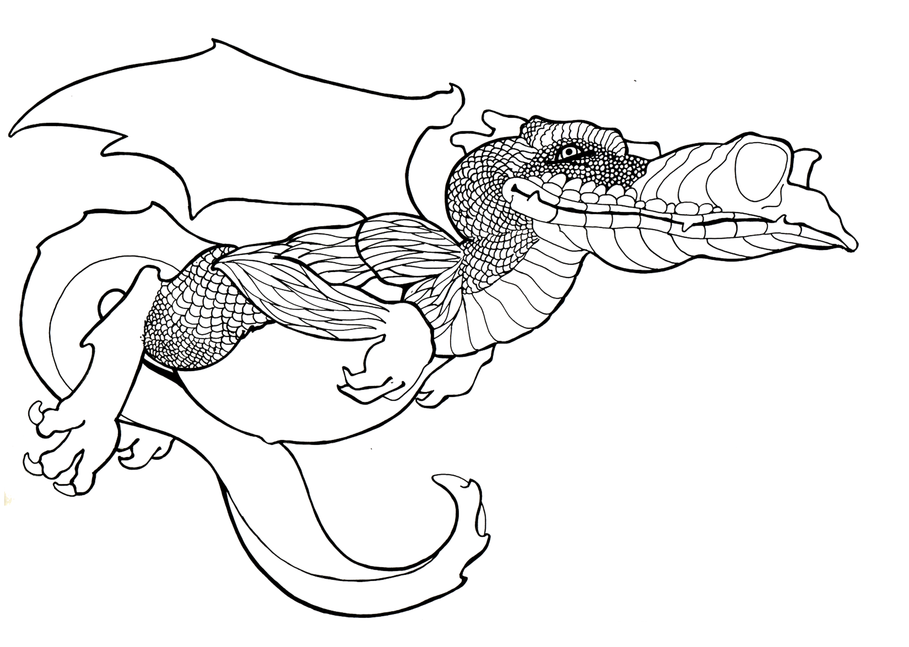
Dragon Project

The purpose of the Dragon Project is to apply the Photoshop skills learned so far in class. The focus of this project is the skills of applying colors, gradients, effects, lighting and texture effects to layers. You want to make the dragon appear as 2 or 3 Dimensional as possible.

Steps
- Open the Dragon Master and save it to your area. Dragon Your LastNameFirst Initial
- Begin on the outline layer (Duplicate it so you have an original You will hide the original)
- Select a segment(s) on the Dragon (pay attention to tolerance, also Select>Modify>Expand 1px).
- Make a new layer via copy, name it with the body part. Make sure you also make use of groups (folders)
- Make sure you lock transparency if you are applying gradients.
- Apply color, lighting and texture effects as appropriate, don’t over do, but do something.
- After you have colored the dragon, add shading, highlights or shadows using masking etc.
- Make an appropriate background, may use a high quality image, however you must edit it so that it has been transformed enough that it appears original and add something/take away… needs to be multiple layers. Try using filters, Filter>Filter Gallery.
- Put name at bottom right corner. Make this part of the art not standard font.
- Print to color printer (Fit it to page) with this copy below it.

Be creative and have fun with this project. Take the time in the beginning to create a mental image of how the Dragon will look. You may choose any colors or textures that you want to use.

Evaluation points: 100 Points

- Overall look of the Dragon – visual appeal, color selection (not all scales have same color)(does it have depth via gradients and effects/textures…—NOT FLAT) (30)
- Does the dragon look whole, Dragon should not have white spots (10)
- Use of layers. Minimum of 40 layers – proper naming /all layers put into folders (Checked on screen) (15)
- Added Shading/shadow highlights/transparency…etc. used to add depth as well. (10)
- Created Appropriate background using brushes and effects Put into its own folder… (10)
- Time—Adequate Amount of time spent on Project, Creativity, additions etc. (10)
- Name put neatly in bottom right corner in appropriate size, color and font. (5)
- Saved as Last Name First Initial Dragon--Put a copy in correct Hand in folder on the Network- Print to Color Printer (10)
____________________________/100

